**Functional Document**

|  |  |
| --- | --- |
| **Application** | NGERP - Centra |
| **Service Bundle** | Inventory Management |
| **Service Request** | Manage Tally Sheet |

**Description :**

Manage Tally Sheet screen is used to purchase gift products. Users should create a NTA AP invoice in HQ to purchase gift products through tally sheet in region. After creating the tally sheet user should confirm the tally sheet using tally sheet confirmation screen.

**Workflow Process :**

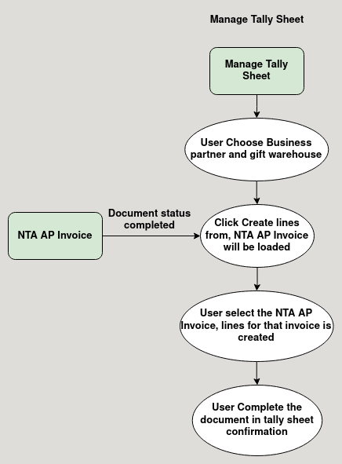

**Business Rules :**

* User can create a new tally sheet in region.
* The document type should be MM receipt.
* User choose the business partner who put NTA AP Invoice in the Manage tally sheet screen.
* User click create lines from and choose the NTA AP Invoice.
* After the line is loaded user can complete the tally sheet in tally sheet confirmation screen to receive the stock in the gift inventory.